## VISVESVARAYA TECHNOLOGICAL UNIVERSITY

#### BELAGAVI, Karnataka -590018

#### INTERNSHIP REPORT

**ON**

# “Sentiment Analysis Of Lockdown In USA During Covid-19 A Case Study On Twitter using ML”

***Submitted in partial fulfilment for the award of degree(18CSI85)***

#### BACHELOR OF ENGINEERING IN COMPUTER SCIENCE AND ENGINEERING

***Submitted by:***

**SOUNDARYA R**

**4GW20CS100**



Conducted at

**Varcons Technologies Pvt Ltd**

**GSSS INSTITUTE OF ENGINEERING AND TECHNOLOGY FOR WOMEN**

**DEPARTMENT OF COMPUTER SCIENCE AND ENGINEERING**

KRS Road, Metagalli, Hebbal Industrial Area,

Mysuru, Karnataka 570016

**GSSS INSTITUTE OF ENGINEERING AND TECHNOLOGY FOR WOMEN**

**DEPARTMENT OF COMPUTER SCIENCE AND ENGINEERING**

K.R.S Road, Metagalli, Mysuru-570016, Karnataka





**CERTIFICATE**

This is to certify that the Internship titled **“Sentiment Analysis Of Lockdown In USA During Covid-19 A Case Study On Twitter using ML”** carried out by **Ms Soundarya R,** a bonafide student of **GSSS Institute of Engineering and Technology for Women** in partial fulfillment for the award of **Bachelor of Engineering**, in **Computer Science and Engineering,** under Visvesvaraya Technological University, Belagavi, during the year 2023-2024. It is certified that all corrections/suggestions indicated have been incorporated in the report.

**Signature of Guide Signature of HOD Signature of Principal**

**External Viva :**

Name of the Examiner Signature with Date

1)

2)

**D E C L A R A T I O N**

I, **SOUNDARYA R(4GW20CS100)**, final year student of Computer Science and Engineering, **GSSS Institute of Engineering and Technology for Women**-570 016, declare that the Internship has been successfully completed, in **Varcons Technologies Pvt Ltd**. This report is submitted in partial fulfillment of the requirements for award of Bachelor Degree in Computer Science and Engineering, during the academic year 2023-2024.

|  |  |  |  |
| --- | --- | --- | --- |
| 20-09-2023  Mysuru |  |  | SOUNDARYA R  4GW20CS100 |
|  |  |  |  |
|  |  |  |  |

**OFFER LETTER**



Internship Offer Letter



Date: 11th August, 2023

Name: **Soundarya R**

USN: **4GW20CS100**

**Dear Student,**

We would like to congratulate you on being selected for the **Machine Learning With Python**

**(Research Based)** Internship position with **Varcons Technologies**, effective Start Date **11th August, 2023**, All of us are excited about this opportunity provided to you!

This internship is viewed as being an educational opportunity for you, rather than a part-time job. As such, your internship will include training/orientation and focus primarily on learning and developing new skills and gaining a deeper understanding of concepts of **Machine Learning With Python (Research Based)** through hands-on application of the knowledge you learn while you train with the senior developers. You will be bound to follow the rules and regulations of the company during your internship duration.

Again, congratulations and we look forward to working with you!.

Sincerely,

Spoorthi H C

**Director**

Varcons Technologies

*213, 2st Floor,*

*18 M G Road, Ulsoor,*

*Bangalore-560001*

### A C K N O W L E D G E M E N T

This Internship is a result of accumulated guidance, direction and support of several important persons. I take this opportunity to express my gratitude to all who have helped me to complete the Internship.

I express my sincere thanks to our Principal **Dr. Shivakumar M**, for providing me adequate facilities to undertake this Internship.

I would like to thank our Head of Dept – CSE branch **Dr. Raviraj P** , for providing me an opportunity to carry out Internship and for his valuable guidance and support.

I express our deep and profound gratitude to our guide, Guide name, Assistant/Associate Prof, for her keen interest and encouragement at every step in completing the Internship.

I would like to thank all the faculty members of our department for the support extended during the course of Internship.

I would like to thank the non-teaching members of our dept, for helping me during the Internship.

Last but not the least, I would like to thank our parents and friends without whose constant help, the completion of Internship would have not been possible.

Soundarya R

4GW20CS100

**ABSTRACT**

In this era of flourishing technology, Social Media has become a powerful platform for the public to voice their concerns and beliefs. Among them one such platform is Twitter. Twitter has been a popular platform for microblogging in the past few years. In this context, Sentiment Analysis is extremely useful in social media monitoring as it allows us to gain an overview of the wider public opinion behind certain topics. Across the past few years, as the organizations and governments across the world start to adopt the ability to extract insights from social data, the applications of sentiment analysis are broad and powerful. There has been a clear implication that shifts in sentiment on social media correlate with shifts in the economics of a country and also the common notion among the public.

Due to the recent COVID-19 pandemic, there has been a wide change in sentiments of various sectors of the Indian public towards the government policies/actions. Studying the sentiment of the people on the epidemic and government decisions is very important as it acts as a sanity check for the effectiveness of the adopted government policies. This study also provides insight into the business models required to be adopted to suit this new age of post-COVID-19 where people’s sentiments have widely changed. In this context ‘Sentiment Analysis of COVID-19 Tweets’ is a very important problem statement.

#### Table of Contents

|  |  |  |
| --- | --- | --- |
| **SI no** | **Description** | **Page no** |
| 1 | Company Profile | 1 |
| 2 | About the company | 2 |
| 3 | Introduction | 6 |
| 4 | System Analysis | 7 |
| 5 | Requirement Analysis | 10 |
| 6 | System Design | 11 |
| 7 | Implementation | 13 |
| 8 | Snapshots | 20 |
| 9 | Conclusion |  |
| 10 | References |  |

[**CHAPTER**](https://1.bp.blogspot.com/-dODuK8N5h1Q/Wlnyb3V9HFI/AAAAAAAACL4/WxQtCJ1pM5wccDABg4wIrTBUB0vlikXQQCLcBGAs/s1600/poly1.jpg)  **1**

**COMPANY PROFILE**

**1.COMPANY PROFILE**

A Brief History of Varcons Technologies Pvt Ltd

Varcons Technologies Pvt Ltd, was incorporated with a goal “To provide high quality and optimal Technological Solutions to business requirements of our clients”. Every business is a different and has a unique business model and so are the technological requirements. They understand this and hence the solutions provided to these requirements are different as well.

They focus on clients requirements and provide them with tailor made technological solutions. They also understand that Reach of their Product to its targeted market or the automation of the existing process into e-client and simple process are the key features that our clients desire from Technological Solution they are looking for and these are the features that we focus on while designing the solutions for their clients.

Sarvamoola Software Services. is a Technology Organization providing solutions for all web design and development, MYSQL, PYTHON Programming, HTML, CSS, ASP.NET and LINQ. Meeting the ever increasing automation requirements, Sarvamoola Software Services.

Specialize in ERP, Connectivity, SEO Services, Conference Management, effective web promotion and tailor-made software products, designing solutions best suiting clients requirements. Varcons Technologies Pvt Ltd, strive to be the front runner in creativity and innovation in software development through their well-researched expertise and establish it as an out of the box software development company in Bangalore, India. As a software development company, they translate this software development expertise into value for their customers through their professional solutions.

They understand that the best desired output can be achieved only by understanding the clients demand better. Compsoft Technologies work with their clients and help them to defiine their exact solution requirement. Sometimes even they wonder that they have completely redefined their solution or new application requirement during the brainstorming session, and here they position themselves as an IT solutions consulting group comprising of high caliber consultants.

They believe that Technology when used properly can help any business to scale and achieve new heights of success. It helps Improve its efficiency, profitability, reliability; to put it in one sentence.Technology helps you to Delight your Customers” and that is what we want to achieve.

# [CHAPTER](https://1.bp.blogspot.com/-dODuK8N5h1Q/Wlnyb3V9HFI/AAAAAAAACL4/WxQtCJ1pM5wccDABg4wIrTBUB0vlikXQQCLcBGAs/s1600/poly1.jpg) 2 ABOUT THE COMPANY

#### 2.ABOUT THE COMPANY



Varcons Technologies Pvt Ltd is a Technology Organization providing solutions for all web design and development, MYSQL, PYTHON Programming, HTML, CSS, ASP.NET and LINQ. Meeting the ever increasing automation requirements, Compsoft Technologies specialize in ERP, Connectivity, SEO Services, Conference Management, effective web promotion and tailor-made software products, designing solutions best suiting clients requirements. The organization where they have a right mix of professionals as a stakeholders to help us serve our clients with best of our capability and with at par industry standards. They have young, enthusiastic, passionate and creative Professionals to develop technological innovations in the field of Mobile technologies, Web applications as well as Business and Enterprise solution. Motto of our organization is to “Collaborate with our clients to provide them with best Technological solution hence creating Good Present and Better Future for our client which will bring a cascading a positive effect in their business shape as well”. Providing a Complete suite of technical solutions is not just our tag line, it is Our Vision for Our Clients and for Us, We strive hard to achieve it.

Products of Varcons Technologies Pvt Ltd.

Android Apps

It is the process by which new applications are created for devices running the Android operating system. Applications are usually developed in Java (and/or Kotlin; or other such option) programming language using the Android software development kit (SDK), but other development environments are also available, some such as Kotlin support the exact same Android APIs (and bytecode), while others such as Go have restrictedAPI access.

The Android software development kit includes a comprehensive set of development tools. These include a debugger, libraries, a handset emulator based on QEMU, documentation, sample code, and Tutorials. Currently supported development platforms include computers running Linux (any modern desktop Linux distribution), Mac OS X 10.5.8 or later, and Windows 7 or later. As of March 2015, the SDK is not available on Android itself, but software development is possible by using specialized Android applications.

##### Web Application

It is a client–server computer program in which the client (including the user interface and client- side logic) runs in a web browser. Common web applications include web mail, online retail sales, online auctions, wikis, instant messaging services and many other functions. web applications use web documents written in a standard format such as HTML and JavaScript, which are supported by a variety of web browsers. Web applications can be considered as a specific variant of client–server software where the client software is downloadedto the client machine when visiting the relevant web page, using standard procedures such as HTTP. The Client web software updates may happen each time the web page is visited. During the session, the web browser interprets and displays the pages, and acts as the universal client for any web application. The use of web application frameworks can often reduce the number of errors in a program, both by making the code simpler, and by allowing one team to concentrate on the framework while another focuses on a specified use case. In applications which are exposed to constant hacking attempts on the Internet, security related problems can be caused by errors in the program.

Frameworks can also promote the use of best practices such as GET after POST. There are some who view a web application as a two-tier architecture. This can be a “smart” client that performs all the work and queries a “dumb” server, or a “dumb” client that relies on a “smart” server. The client would handle the presentation tier, the server would have the database (storage tier), and the business logic (application tier) would be on one of them or on both. While this increases the scalability of the applications and separates the display and the database, it still doesn‟t allow for true specialization of layers, so most applications will outgrow this model. An emerging strategy for application software companies is to provide web access to software previously distributed as local applications. Depending on the type of application, it may require the development of an entirely different browser-based interface, or merely adapting an existing application to use different presentation technology. These programs allow the user to pay a monthly or yearly fee for use of a software application without having to install it on a local hard drive. A company which follows this strategy is known as an application service provider (ASP), and ASPs are currently receiving much attention in the software industry.

Security breaches on these kinds of applications are a major concern because it can involve both enterprise information and private customer data. Protecting these assets is an important part of any web application and there are some key operational areas that must be included in the development process. This includes processes for authentication, authorization, asset handling, input, and logging and auditing. Building security into the applications from the beginning can be more effective and less disruptive in the long run.

##### Web design

It is encompassing many different skills and disciplines in the production and maintenance of websites. The different areas of web design include web graphic design; interface design; authoring, including standardized code and proprietary software; user experience design; an search engine optimization. The term web design is normally used to describe the design process relating to the front-end (client side) design of a website including writing mark up. Web design partially overlaps web engineering in the broader scope of web development. Web designers are expected to have an awareness of usability and if their role involves creating markup then they are also expected to be up to date with web accessibility guidelines. Web design partially overlaps web engineering in the broader scope of web development.

##### Departments and services offered

Varcons Technologies Pvt Ltd plays an essential role as an institute, the level of education, development of student’s skills are based on their trainers. If you do not have a good mentor then you may lag in manythings from others and that is why we at Compsoft Technologies gives you the facility of skilled employees so that you do not feel unsecured about the academics.

Personality development and academicstatus are some of those things which lie on mentor’s hands. If you are trained well then you can do well in your future and knowing its importance of Compsoft Technologies always tries to give you the best.

They have a great team of skilled mentors who are always ready to direct their trainees in the best possibleway they can and to ensure the skills of mentors we held many skill development programs as well so thateach and every mentor can develop their own skills with the demands of the companies so that they can prepare a complete packaged trainee.

##### Services provided by Varcons Technologies Pvt Ltd

* Core Java and Advanced Java
* Web services and development
* Dot Net Framework
* Python
* Selenium Testing
* Conference / Event Management Service
* Academic Project Guidance
* On The Job Training
* Software Training

# [CHAPTER](https://1.bp.blogspot.com/-dODuK8N5h1Q/Wlnyb3V9HFI/AAAAAAAACL4/WxQtCJ1pM5wccDABg4wIrTBUB0vlikXQQCLcBGAs/s1600/poly1.jpg) 3 INTRODUCTION

#### 3.INTRODUCTION

# 

The outbreak of COVID-19 caused heavy disruption to the everyday lives of people across the globe. In a country like with a large, diverse population like India, there are bound to be instancesof mass hysteria and panic which are further fueled by unreliable and sometimes inaccurate data. Gauging the feelings/emotions of the citizens would provide insights into the public mindset and would pave the way for the government and many organizations to address these situations by providing them with the right data and information, eradicating fake news, thereby helping in suppressing unnecessary panic among the people. Social media acts as the bridge between the people, the government, and such organizations. The scope of this project lies in the application of sentiment analysis to the views expressed by people on social media, twitter, in this case, to analyze the trends in the dynamic mood of the population. Usually, the terms “fight” and “positive” are used in a negative and positive context respectively, but we observe a role reversal in this situation. The identification of such terms and their usage according to the context would be an essential part of the project. Also, the scope of the project can be found in stopping the spread of fake news related to the pandemic, creating an interactive dashboard that delivers information about the current situation, real-time sentiment analysis of tweets, trend analysis of various COVID-19 related hashtags, engagement on Twitter, overall sector-wise polarity score ofthe tweets and the public emotion charts.

**PROBLEM STATEMENT**

Build a python application that asks for a keyword and you need to identify the sentiment of that keyword using an open source dataset.

# [CHAPTER](https://1.bp.blogspot.com/-dODuK8N5h1Q/Wlnyb3V9HFI/AAAAAAAACL4/WxQtCJ1pM5wccDABg4wIrTBUB0vlikXQQCLcBGAs/s1600/poly1.jpg) 4 SYSTEM ANALYSIS

**4.SYSTEM ANALYSIS**

**1.Existing System:**

Initially, the IEEE Coronavirus (COVID-19) Tweets Data set was downloaded from their website. Upon inspection, it was found that many tweets did not have geo-location tags, and also many were in different languages apart from English. Due to this challenge in obtaining proper data, a new data set named Geo-Tagged Coronavirus (COVID-19) Tweets Data set was obtained from the same website. These tweets were then hydrated using the “Hydrater” software and also a few python commands. Then, tweets in “English” and tweets from “India” were randomly chosen and a new dataset was created. Further, other data set containing COVID-19 related tweets from India were obtained from Kaggle. This data set was then cleaned and normalized to make it useful for further analysis.

After Exploratory Data Analysis is completed, the tweets are then Tokenized and are made in a format suitable for the Language Model. In this Step, two models were used:

* Roberta Model: Transfer learning methods were implemented to carry out sentiment analysis. Sentiment Analysis of Tweets was carried out by integrating and using both the Huggingface Transformer Library and FastAI. Further Slanted Triangular Learning Rates, Discriminate Learning Rate and even Gradual Unfreezing were used, as a result of which, state-of-the-art results were obtained rapidly without even tuning the parameters. The tokenized data was then passed through the RoBERTa model to perform Sentiment Analysis. This yielded a model with an accuracy of 97% over the data set. The Tweepy API was used to scrape tweets in real-time which were then passed through the model to obtain the sentiments.
* RoBERTa-CNN Sentiment Extractor: After the completion of the sentiment analysis the data was further explored for the sentiment triggers in the tweets. HuggingFace transformers don't have a TFRoberta For Question Answering, for this purpose, a TFRobertaModel was created to convert trained data into arrays that the Roberta model can interpret. While training the Sentiment Extractor model, 5 stratified KFolds were used in such a way that, in each fold, the best model weights were saved and these weights were reloaded before carrying out testing and predictions. Roberta with CNN head was used for Twitter Sentiment Extraction. Thus after passing the data through this model we obtained a new column of the extracted text for the sentiments which was also used to plot certain graphs.

Now the entire process pertaining to the data and Model building is completed. Now, the Flask APP is built for the purpose of Deployment. First, the application is deployed on the localhost and debugged and then we move on to deploying on the WebServers.

A flask app was used for setting up website routing. It is used to integrate the back end machine learning models with the dashboard. Then Socketio (web sockets) were used for dynamic implementations on the website, namely the Real-Time Plot Generators and Twitter live feed. The basic functionality of the Flask Socketio lies in running background threads when the client is not connected to the website thereby enabling dynamic plotting. The above built Dashboard was deployed on the Local Machine and debugged for any possible errors. The scraping rate and other parameters were monitored and corrected accordingly models with the dashboard. Then Socketio (web sockets) were used for dynamic implementations on the website, namely the Real-Time Plot Generators and Twitter live feed. The basic functionality of the Flask Socketio lies in running background threads when the client is not connected to the website thereby enabling dynamic plotting. The above built Dashboard was deployed on the Local Machine and debugged for any possible errors. The scraping rate and other parameters were monitored and corrected accordingly.

**2.Proposed System:**

The proposed system for sentiment analysis of lockdown in the USA during COVID-19 on Twitter using ML consists of the following steps:

Data collection: Collect tweets using the keywords "lockdown" and "COVID-19" from a specific period of time.

Data preprocessing: Clean and preprocess the tweets, such as removing stop words, hashtags, and mentions.

Feature extraction: Extract features from the preprocessed tweets, such as TF-IDF, n-grams, and Word2Vec.

Model training: Train a machine learning classifier to predict the sentiment of the tweets, using the extracted features as input.

Model evaluation: Evaluate the performance of the trained model on a held-out test set.

Sentiment analysis: Use the trained model to predict the sentiment of new tweets about lockdown in the USA during COVID-19.

**3.Objective of the System:**

The objective of a system for sentiment analysis of the lockdown in the USA during COVID-19, using Twitter data and machine learning, could be to:

* Understand Public Sentiment: Analyze Twitter data to gauge the sentiment (positive, negative, neutral) of people's opinions and emotions regarding the lockdown measures.
* Identify Trends: Identify trends and patterns in sentiment over time, such as shifts in sentiment during different phases of lockdown or in response to specific events.
* Assess Impact: Evaluate the impact of lockdown measures on public sentiment, including factors that contribute to changes in sentiment.
* Provide Insights: Offer valuable insights to policymakers, healthcare authorities, and the public to make informed decisions about COVID-19 responses.
* Improve Communication: Enhance communication strategies by understanding how information is being disseminated and received on Twitter during the lockdown.
* Machine Learning Model: Develop a machine learning model (e.g., Natural Language Processing with sentiment analysis algorithms) to automate sentiment classification of tweets.
* Visualization: Visualize sentiment data through graphs and charts to make it more accessible and interpretable.
* User Engagement: Encourage user engagement by soliciting feedback and responses from the Twitter community to understand their concerns and suggestions.
* Predictive Analysis: Use historical sentiment data to make predictive analyses, like forecasting potential sentiment shifts in response to future events or policy changes.
* Ethical Considerations: Ensure that the sentiment analysis respects privacy and ethical guidelines, considering the potential biases in the data and the importance of protecting individuals' identities.

Ultimately, the goal is to gain insights into public sentiment surrounding the lockdown, helping authorities make informed decisions and improving communication during challenging times like the COVID-19 pandemic.

# [CHAPTER](https://1.bp.blogspot.com/-dODuK8N5h1Q/Wlnyb3V9HFI/AAAAAAAACL4/WxQtCJ1pM5wccDABg4wIrTBUB0vlikXQQCLcBGAs/s1600/poly1.jpg) 5 REQUIREMENT ANALYSIS

# 5.REQUIREMENT ANALYSIS

**Hardware Requirement Specification:**

* **System : 4Core Processors**
* **Hard Disk : 142 GB**
* **Ram : 4 GB**

**Software Requirement Specification:**

* **Jupyter Notebook**
* **Python version 3.11.0 and above**

# [CHAPTER](https://1.bp.blogspot.com/-dODuK8N5h1Q/Wlnyb3V9HFI/AAAAAAAACL4/WxQtCJ1pM5wccDABg4wIrTBUB0vlikXQQCLcBGAs/s1600/poly1.jpg) 6 DESIGN ANALYSIS

# 6.DESIGN & ANALYSIS

Designing a sentiment analysis system for studying the lockdown in the USA during COVID-19 on Twitter using machine learning involves several key steps and considerations:

Data Collection: Acquire Twitter data related to the lockdown in the USA during COVID-19. This can be done using the Twitter API or by purchasing a dataset from a reputable source.Ensure that the dataset includes relevant tweets, user information, and timestamps.

Data Preprocessing: Clean and preprocess the raw data by removing noise, such as special characters, URLs, and irrelevant symbols. Tokenize the text into individual words or phrases.

Perform stemming or lemmatization to reduce words to their base form. Handle missing data and duplicates appropriately.

Labeling Data: Manually label a subset of the dataset for training and validation. Label tweets as positive, negative, or neutral sentiments. Consider using crowdsourcing platforms for larger datasets.

Feature Extraction: Convert the text data into numerical features suitable for machine learning models. Common techniques include TF-IDF (Term Frequency-Inverse Document Frequency) or word embeddings like Word2Vec or GloVe.

Model Selection: Choose a machine learning algorithm suitable for sentiment analysis. Common choices include Support Vector Machines (SVM), Random Forest, or deep learning models like LSTM or BERT. Fine-tune the chosen model's hyperparameters using cross-validation.

Training: Train the selected model on the labeled data using an appropriate loss function (e.g., binary cross-entropy for binary classification). Monitor training metrics like accuracy, precision, recall, and F1-score.

Validation: Evaluate the model's performance on a validation dataset to assess its generalization capabilities. Adjust the model or preprocessing steps as needed based on validation results.

Testing: Test the trained model on a separate test dataset to measure its real-world performance.

Visualization: Create visualizations such as confusion matrices, ROC curves, or word clouds to provide insights into sentiment patterns.

Real-Time Analysis: If desired, implement a system that can perform sentiment analysis on new Twitter data in real-time by integrating the model with the Twitter API.

Ethical Considerations: Ensure that privacy and ethical guidelines are followed when handling Twitter data, and respect user privacy and anonymity.

Interpretation and Reporting: Interpret the results and report on sentiment trends during different phases of the lockdown. Discuss the implications and potential applications of the findings.

Feedback Loop: Continuously monitor and update the model as new data becomes available or as sentiment analysis needs evolve.

Documentation and Deployment: Document the entire process, including data sources, preprocessing steps, model architecture, and performance metrics. Deploy the sentiment analysis system in a scalable and maintainable manner for ongoing analysis.

User Engagement: Engage with stakeholders and users to gather feedback and improve the system's usefulness and accuracy.

By following these steps, you can design and implement an effective sentiment analysis system for studying the lockdown sentiments on Twitter during the COVID-19 pandemic in the USA using machine learning techniques**.**

**FLOW CHART:**

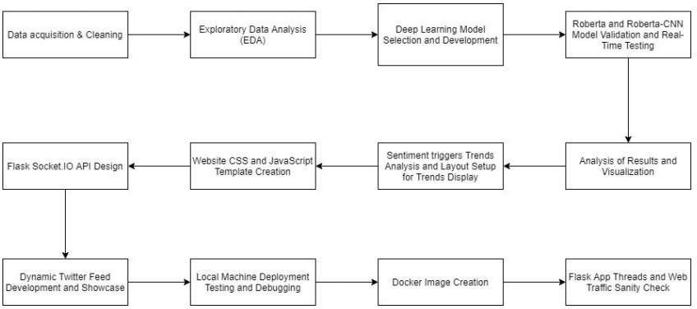

# [CHAPTE](https://1.bp.blogspot.com/-dODuK8N5h1Q/Wlnyb3V9HFI/AAAAAAAACL4/WxQtCJ1pM5wccDABg4wIrTBUB0vlikXQQCLcBGAs/s1600/poly1.jpg)R 7 IMPLEMENTATION

**7.IMPLEMENTATION**

Implementation is the stage where the theoretical design is turned into a working system. The most crucial stage in achieving a new successful system and in giving confidence on the new system for the users that it will work efficiently and effectively.

The system can be implemented only after thorough testing is done and if it is found to work according to the specification. It involves careful planning, investigation of the current system and it constraints on implementation, design of methods to achieve the change over and an evaluation of change over methods a part from planning.

Two major tasks of preparing the implementation are education and training of the users and testing of the system. The more complex the system being implemented, the more involved will be the system analysis and design effort required just for implementation.

The implementation phase comprises of several activities. The required hardware and software acquisition is carried out. The system may require some software to be developed. For this, programs are written and tested. The user then changes over to his new fully tested system and the old system is discontinued.

## TESTING

The testing phase is an important part of software development. It is the Information zed system will help in automate process of finding errors and missing operations and also a complete verification to determine whether the objectives are met and the user requirements are satisfied. Software testing is carried out in three steps:

1. The first includes unit testing, where in each module is tested to provide its correctness, validity and also determine any missing operations and to verify whether the objectives have been met. Errors are noted down and corrected immediately.
2. Unit testing is the important and major part of the project. So errors are rectified easily in particular module and program clarity is increased. In this project entire system is divided into several modules and is developed individually. So unit testing is conducted to individual modules.
3. The second step includes Integration testing. It need not be the case, the software whose modules when run individually and showing perfect results, will also show perfect results when run as a whole.

**Pseudocode:**

import pandas as pd import numpy as np import re

import seaborn as sns

import matplotlib.pyplot as plt from matplotlib

import style style.use('ggplot')

%matplotlib inline from textblob

import TextBlob from nltk.tokenize

import word_tokenize from nltk.stem

import PorterStemmer from nltk.corpus

import stopwords

stop_words = set(stopwords.words('english'))

from wordcloud

import WordCloud from sklearn.feature_extraction.text import CountVectorizer from sklearn.model_selection import train_test_split from sklearn.linear_model

import LogisticRegression

import csv from sklearn.metrics

import accuracy_score, classification_report, confusion_matrix, ConfusionMatrixDisplay

df = pd.read_csv('vaccination_tweets.csv') df.head()

df.info() df.isnull().sum() df.columns

text_df = df.drop(['id', 'user_name', 'user_location', 'user_description', 'user_created', 'user_followers', 'user_friends', 'user_favourites', 'user_verified', 'date', 'hashtags', 'source', 'retweets', 'favorites', 'is_retweet'], axis=1)

text_df.head()

print(text_df['text'].iloc[0],"\n")

print(text_df['text'].iloc[1],"\n")

print(text_df['text'].iloc[2],"\n")

print(text_df['text'].iloc[3],"\n")

print(text_df['text'].iloc[4],"\n")

text_df.info()

def data_processing(text):

text = text.lower()

text = re.sub(r"https\S+|www\S+https\S+", '', text, flags=re.MULTILINE)

text = re.sub(r'\@w+|\#','',text) text = re.sub(r'[^\w\s]','',text) text_tokens = word_tokenize(text)

filtered_text = [w for w in text_tokens if not w in stop_words]

return " ".join(filtered_text)

text_df.text = text_df['text'].apply(data_processing)

text_df = text_df.drop_duplicates('text')

stemmer = PorterStemmer()

def stemming(data):

text = [stemmer.stem(word) for word in data]

return data

text_df['text'] = text_df['text'].apply(lambda x: stemming(x))

text_df.head()

print(text_df['text'].iloc[0],"\n")

print(text_df['text'].iloc[1],"\n")

print(text_df['text'].iloc[2],"\n")

print(text_df['text'].iloc[3],"\n")

print(text_df['text'].iloc[4],"\n") text_df.info()

def polarity(text):

return TextBlob(text).sentiment.polarity

text_df['polarity'] = text_df['text'].apply(polarity) text_df.head(10)

def sentiment(label):

if label < 0:

return "Negative"

elif label == 0:

return "Neutral"

elif label>0:

return "Positive"

text_df['sentiment'] = text_df['polarity'].apply(sentiment)

text_df.head()

fig = plt.figure(figsize=(5,5))

sns.countplot(x='sentiment',

data = text_df)

fig = plt.figure(figsize=(7,7))

colors = ("yellowgreen", "gold", "red")

wp = {'linewidth':2, 'edgecolor':"black"}

tags = text_df['sentiment'].value_counts()

explode = (0.1,0.1,0.1)

tags.plot(kind='pie', autopct='%1.1f%%', shadow=True, colors = colors, startangle=90, wedgeprops = wp, explode = explode, label='')

plt.title('Distribution of sentiments')

pos_tweets = text_df[text_df.sentiment == 'Positive']

pos_tweets = pos_tweets.sort_values(['polarity'], ascending= False)

pos_tweets.head()

text = ' '.join([word for word in pos_tweets['text']]) plt.figure(figsize=(20,15), facecolor='None')

wordcloud = WordCloud(max_words=500, width=1600, height=800).generate(text)

plt.imshow(wordcloud, interpolation='bilinear')

plt.axis("off")

plt.title('Most frequent words in positive tweets', fontsize=19)

plt.show()

neg_tweets = text_df[text_df.sentiment == 'Negative']

neg_tweets = neg_tweets.sort_values(['polarity'], ascending= False)

neg_tweets.head()

text = ' '.join([word for word in neg_tweets['text']])

plt.figure(figsize=(20,15), facecolor='None')

wordcloud = WordCloud(max_words=500, width=1600, height=800).generate(text)

plt.imshow(wordcloud, interpolation='bilinear')

plt.axis("off")

plt.title('Most frequent words in negative tweets', fontsize=19)

plt.show()

neutral_tweets = text_df[text_df.sentiment == 'Neutral']

neutral_tweets = neutral_tweets.sort_values(['polarity'], ascending= False)

neutral_tweets.head()

text = ' '.join([word for word in neutral_tweets['text']]) plt.figure(figsize=(20,15), facecolor='None')

wordcloud = WordCloud(max_words=500, width=1600, height=800).generate(text)

plt.imshow(wordcloud, interpolation='bilinear')

plt.axis("off")

plt.title('Most frequent words in neutral tweets', fontsize=19)

plt.show()

vect = CountVectorizer(ngram_range=(1,2)).fit(text_df['text'])

feature_names = vect.get_feature_names()

print("Number of features: {}\n".format(len(feature_names)))

print("First 20 features:\n {}".format(feature_names[:20]))

X = text_df['text']

Y = text_df['sentiment']

X = vect.transform(X)

x_train, x_test, y_train, y_test = train_test_split(X, Y, test_size=0.2, random_state=42)

print("Size of x_train:", (x_train.shape))

print("Size of y_train:", (y_train.shape))

print("Size of x_test:", (x_test.shape))

print("Size of y_test:", (y_test.shape))

import warnings warnings.filterwarnings('ignore')

logreg = LogisticRegression()

logreg.fit(x_train, y_train)

logreg_pred = logreg.predict(x_test)

logreg_acc = accuracy_score(logreg_pred, y_test)

print("Test accuracy: {:.2f}%".format(logreg_acc*100)) print(confusion_matrix(y_test, logreg_pred))

print("\n")

print(classification_report(y_test, logreg_pred))

style.use('classic')

cm = confusion_matrix(y_test, logreg_pred, labels=logreg.classes_)

disp = ConfusionMatrixDisplay(confusion_matrix = cm, display_labels=logreg.classes_)

disp.plot()

from sklearn.model_selection import GridSearchCV param_grid={'C':[0.001, 0.01, 0.1, 1, 10]}

grid = GridSearchCV(LogisticRegression(), param_grid)

grid.fit(x_train, y_train)

print("Best parameters:", grid.best_params_)

y_pred = grid.predict(x_test)

logreg_acc = accuracy_score(y_pred, y_test)

print("Test accuracy: {:.2f}%".format(logreg_acc*100)) print(confusion_matrix(y_test, y_pred))

print("\n")

print(classification_report(y_test, y_pred))

from sklearn.svm import LinearSVC

SVCmodel = LinearSVC() SVCmodel.fit(x_train, y_train)

svc_pred = SVCmodel.predict(x_test)

svc_acc = accuracy_score(svc_pred, y_test)

print("test accuracy: {:.2f}%".format(svc_acc*100)) print(confusion_matrix(y_test, svc_pred))

print("\n")

print(classification_report(y_test, svc_pred))

grid = {

'C':[0.01, 0.1, 1, 10],

'kernel':["linear","poly","rbf","sigmoid"], 'degree':[1,3,5,7],

'gamma':[0.01,1]

}

grid = GridSearchCV(SVCmodel, param_grid) grid.fit(x_train, y_train)

print("Best parameter:", grid.best_params_)

y_pred = grid.predict(x_test)

logreg_acc = accuracy_score(y_pred, y_test)

print("Test accuracy: {:.2f}%".format(logreg_acc*100)) print(confusion_matrix(y_test, y_pred))

print("\n")

print(classification_report(y_test, y_pred))

import tweepy #to access the twitter api

import pandas as pd #for basic data operations # Importing the keys from twitter api

consumerKey = "xxxxxxxxxxxxxxxxxxxx"

consumerSecret = "xxxxxxxxxxxxxxxxxxxx"

accessToken = "xxxxxxxxxxxxxxxxxxxx"

accessTokenSecret = "xxxxxxxxxxxxxxxxxxxx"

# Establish the connection with twitter API

auth = tweepy.OAuthHandler(consumerKey, consumerSecret) auth.set_access_token(accessToken, accessTokenSecret)

api = tweepy.API(auth)

# Search for the Term and define number of tweets

searchTerm = input("Enter Keyword/Tag to search about: ")

NoOfTerms = int(input("Enter how many tweets to search: ")) # Get no of tweets and searched term together

tweets=tweepy.Cursor(api.search_tweets,q=searchTerm).items(NoOfTerms)

**CHAPTER 8**

**SNAPSHOTS**

**8.SNAPSHOTS**

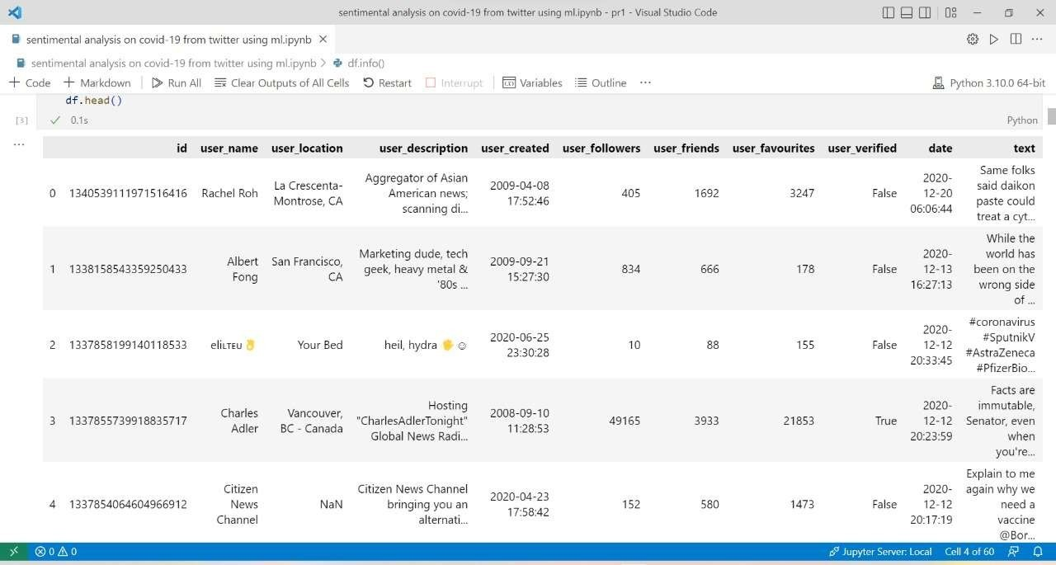

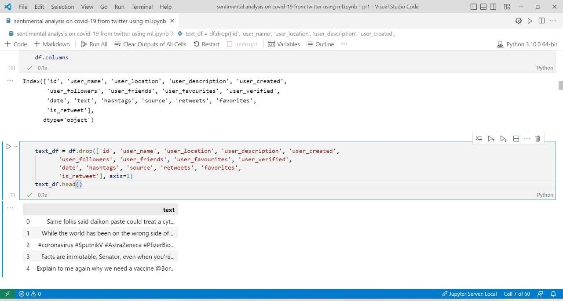

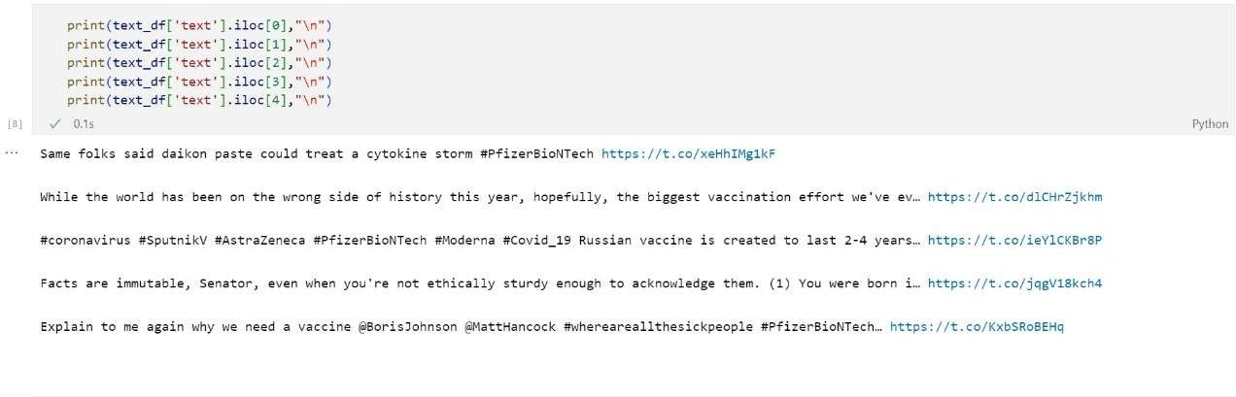

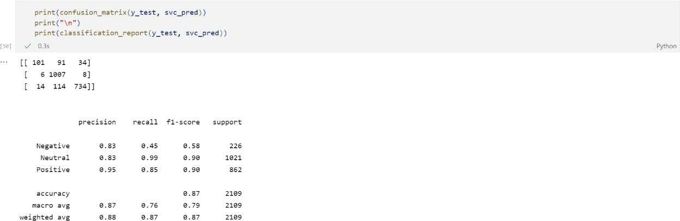

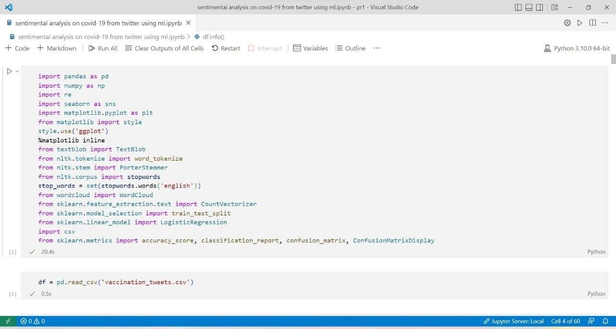



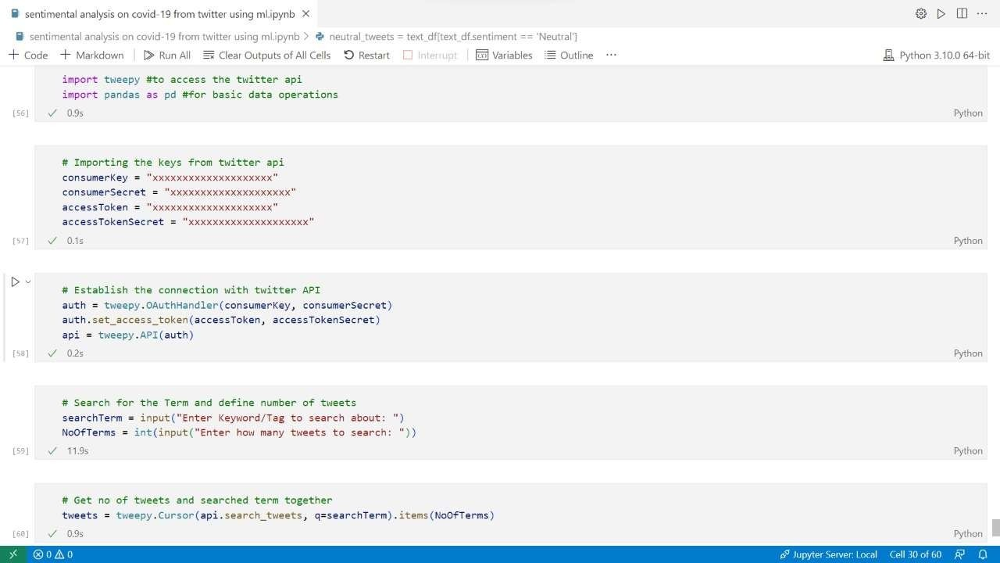

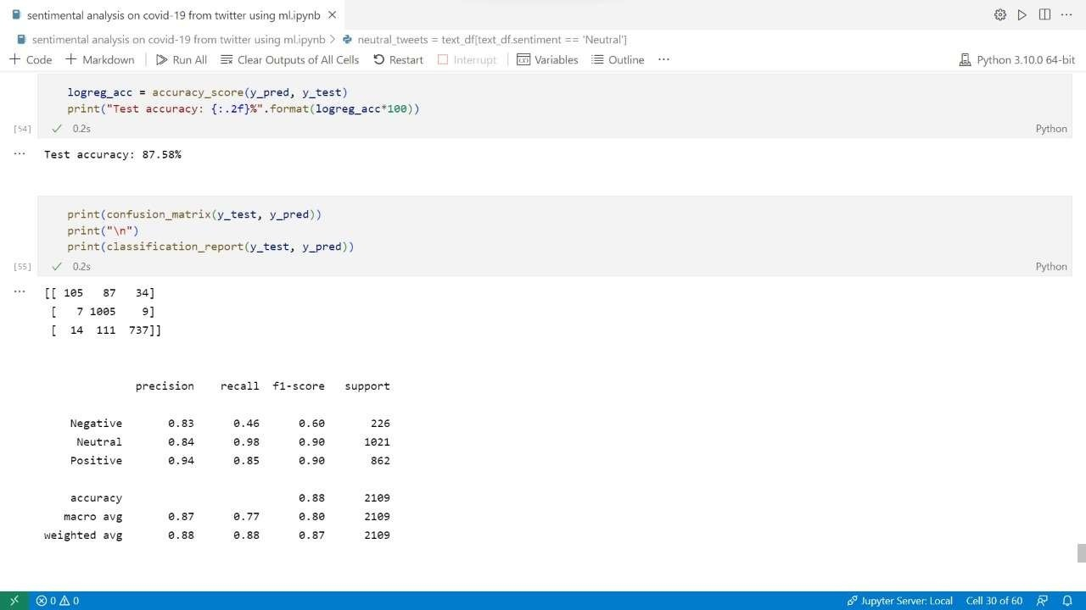

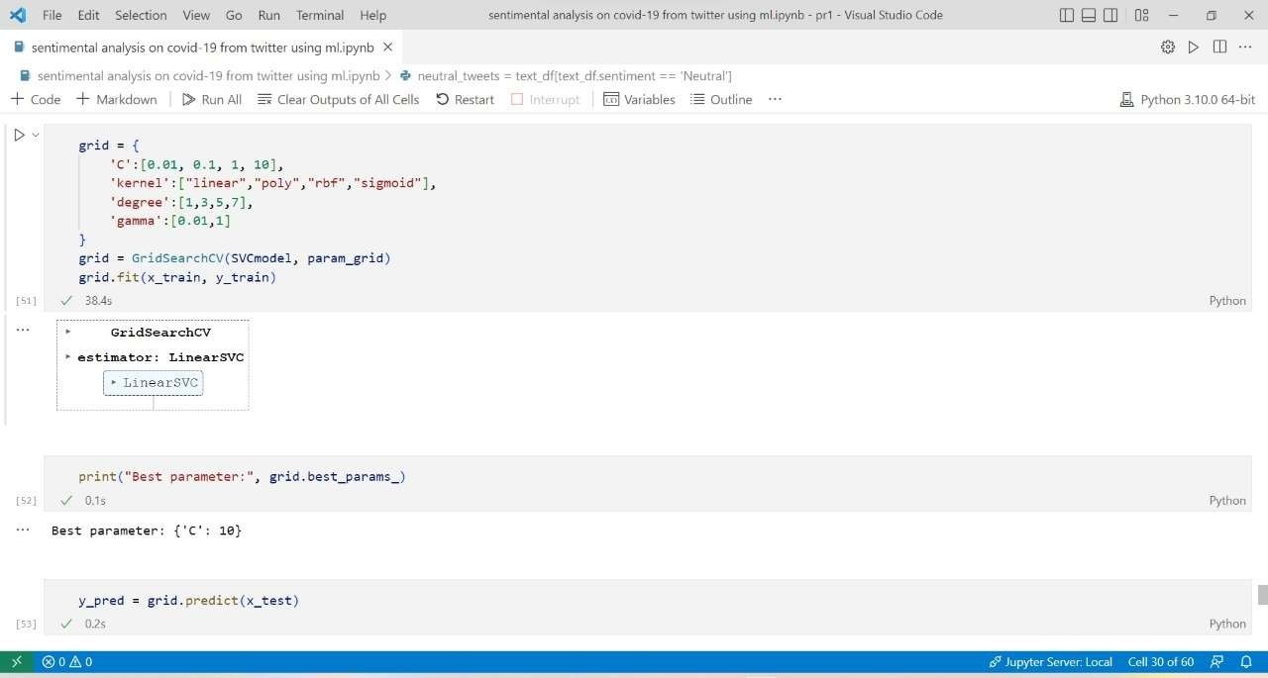

**ADVANTAGES AND DISADVANTAGES:**

**ADVANTAGES:**

The effect of COVID-19 pandemic is visible all over the world. National healthcare systems are facing the contagion with incredible strength, but concern regarding psychosocial and economic effects is critically growing. In a fast-moving crisis, as information swarms in from every direction, citizens look to their governments for information, guidance, and leadership. Sentimental Analysis is only the option in this current situation to understand the psychological condition/mental condition of the public. By Sentimental Analysis, the public opinion on COVID-19, regime policies, and actions can be understood. After Analysis, amendments can be made to the decisions taken by the regime policies, and the public can be fortified in such a way so as to enhance the sentiment towards a positive outlook. Not only this but also sentiment analysis will help NGOs and various organizations to come forward to help the people. Businesses can adapt their products and services to match the requirements of the people based on the real-time trending mood of the public, which will notonly help businesses to grow but will also help the public meet their need of the hour. Also, this will enable the government to make business and people-friendly rules and laws to help in the betterment of the economy and the market in these untested times.

**DISADVANTAGES:**

Natural Language Processing models, in general, face a problem in recognizing human aspects of a language like irony, sarcasm, negotiations, exaggerations, and jokes - the sortsof things humans wouldn’t face many problems in understanding. Machines sometimes fail in recognizing these aspects, which leads to skewed and incorrect results.

**CONCLUSION**

Sentiment analysis or opinion mining is a hot topic in deep learning. There is still a long way to go before sentiments can be accurately detected from texts, because of the complexity involved in the English language, and even more when other languages like Hindi are considered. Though the Roberta model developed as a part of this project has predicted and classified the sentiments of the test data set into positive, negative and neutral categories with an accuracy of 97%, by making necessary modifications and additions to the model, sentiment analysis can be done with greater accuracy by taking the language complexities into consideration.

**REFERENCES**

**Websites**

1.https://www.researchgate.net/publication/347802406_Sentiment_Analysis_of_Lockdown_in_USA_during_COVID-19_A_Case_Study_on_Twitter

2. https://www.frontiersin.org/articles/10.3389/fpubh.2021.812735/full

3. https://takeoffprojects.com/project-details/sentiment-analysis-of-lockdown-in-usa-during-covid-19-a-case-study-on-twitter--13014

4. https://www.kaggle.com/datasets/gpreda/covid19-tweet